**EXPERIMENT 2**

**Study of Network Devices**

**Hub:**

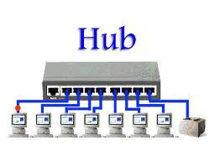 **Hub** is the most basic networking [device](https://www.computerhope.com/jargon/d/device.htm) that connects multiple computers or other network devices together. Unlike a network [switch](https://www.computerhope.com/jargon/s/switch.htm) or [router](https://www.computerhope.com/jargon/r/router.htm), a network hub has no routing tables or intelligence on where to send information and [broadcasts](https://www.computerhope.com/jargon/b/broadcas.htm) all network data across each connection. Most hubs can detect basic network errors such as collisions, but having all information broadcast to multiple ports can be a security risk and cause bottlenecks. In the past, network hubs were popular because they were cheaper than a switch or router. Today, switches do not cost much more than a hub and are a much better solution for any network.

**Types of Hub**: On the basis of its working methods, the Hubs can be divided into three types, given as:

* Active Hub
* Passive Hub
* Intelligent Hub

**Active Hub**: As its name suggests, Active Hub is a hub which can amplify or regenerate the information signal. This type of bus has an advantage as it also amplifies the incoming signal as well as forward it to multiple devices. This Bus is also known as Multiport Repeater. It can upgrade the properties if incoming signal before sending them to destination.

**Passive Hub**: Passive Hub works like a simple Bridge. It is used for just creating a connection between various devices. It does not have the ability to amplify or regenerate any incoming signal. It receives signal and then forward it to multiple devices.

**Intelligent Hub**: This is the third and last type of Bus. It can perform tasks of both Active and Passive buses. Also, it can perform some other tasks like Bridging and routing. It increases the speed and effectiveness of total network thus makes the performance of whole network fast and efficient.

**Ethernet Hub**

In computer networking, a **hub** is a small, simple, inexpensive electronic device that joins multiple computers together.

Until the early 2000s, [Ethernet](https://www.lifewire.com/what-is-ethernet-3426740) hubs were widely used for home networking due to their simplicity and low cost. While [broadband routers](https://www.lifewire.com/what-is-a-broadband-router-816301) have replaced them in homes, hubs still serve a useful purpose. Besides Ethernet, a few other types of networks hubs also exist including [USB](https://www.lifewire.com/universal-serial-bus-usb-2626039) hubs.

### Working with Ethernet Hubs

To network, a group of computers using an Ethernet hub, first connect an [Ethernet cable](https://www.lifewire.com/what-is-an-ethernet-cable-817548) into the unit, then connect the other end of the cable to each computer's [network interface card (NIC)](https://www.lifewire.com/definition-of-nic-817866). All Ethernet hubs accept the [RJ-45](https://www.lifewire.com/definition-of-rj45-817872) connectors of standard Ethernet cables.

To expand a network to accommodate more devices, [Ethernet hubs](https://www.lifewire.com/what-is-an-ethernet-port-817546) can also be connected to each other, to [switches](https://www.lifewire.com/definition-of-network-switch-817588), or to [routers](https://www.lifewire.com/how-routers-work-816456).

### When an Ethernet Hub is Needed

Ethernet hubs operate as [Layer 1](https://www.lifewire.com/osi-model-reference-guide-816289) devices in the [OSI model](https://www.lifewire.com/open-systems-interconnection-model-816290). Although hubs comparable functionality, nearly all mainstream Ethernet network equipment today utilizes [network switch technology](https://www.lifewire.com/definition-of-network-switch-817588) instead, due to the performance benefits of switches.

A hub can be useful for temporarily replacing a broken network switch or when performance is not a critical factor on the network

**Multistation Access Unit**

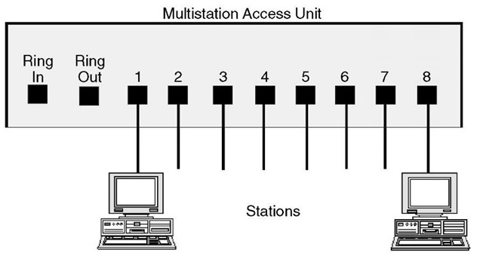

**A Multistation Access Unit (MAU)** is a hub that connects computers and other devices to a token-ring network. The MAU physically connects computers in a star topology while retaining token ring’s logical ring structure. However, every message passes through every computer, each passing it on to the next in a continuing circle until it arrives at its proper destination. This leaves the token-ring topology vulnerable in that a single non-operating node can break the ring. The MAU solves this problem because it has the ability to bypass non-operating nodes and maintain the ring structure.

A Multistation Access Unit is a standalone device or connector that is used to connect devices attached to a network over a token-ring network. Each MSAU includes eight ports.

There are two types of MSAU:

* **Active MSAU** It does not provide any kind of power to the network or to signals.
* **Passive MSAU** It is powered and is used to regenerate or boost network traffic signals.

**MSAU has the following characteristics:**

* Fault Tolerance -An MSAU provides fault tolerance in an established network. This can prevent many network device failures.
* Traffic Bypass-If any computer goes down, the MSAU bypasses the network traffic to provide uninterrupted communication between network nodes.

**Switches**

In a telecommunications network, a switch is a device that channels incoming data from any of multiple input ports to the specific output port that will take the data toward its intended destination. In the traditional [circuit-switched](http://searchnetworking.techtarget.com/definition/circuit-switched) telephone network, one or more switches are used to set up a dedicated though temporary connection or [circuit](http://whatis.techtarget.com/definition/circuit) for an exchange between two or more parties. On an [Ethernet](http://searchnetworking.techtarget.com/definition/Ethernet) local area network (LAN), a switch determines from the physical device (Media Access Control or MAC) address in each incoming message [frame](http://searchnetworking.techtarget.com/definition/frame) which output port to forward it to and out of. In a wide area [packet-switched](http://searchnetworking.techtarget.com/definition/packet-switched) network such as the [Internet](http://searchwindevelopment.techtarget.com/definition/Internet), a switch determines from the [IP address](http://searchwindevelopment.techtarget.com/definition/IP-address) in each [packet](http://searchnetworking.techtarget.com/definition/packet) which output port to use for the next part of its trip to the intended destination.

In the Open Systems Interconnection ([OSI](http://searchnetworking.techtarget.com/definition/OSI)) communications model, a switch performs the [Layer 2](http://searchnetworking.techtarget.com/definition/layer-2) or [Data-link layer](http://searchnetworking.techtarget.com/definition/Data-Link-layer) function. That is, it simply looks at each packet or data unit and determines from a physical address (the "MAC address") which device a data unit is intended for and switches it out toward that device. However, in wide area networks such as the Internet, the destination address requires a look-up in a routing table by a device known as a [router](http://searchnetworking.techtarget.com/definition/router). Some newer switches also perform routing functions ([Layer 3](http://searchunifiedcommunications.techtarget.com/definition/layer-3) or the [Network layer](http://searchnetworking.techtarget.com/definition/Network-layer) functions in OSI) and are sometimes called IP switches.

On larger networks, the trip from one switch point to another in the network is called a [hop](http://whatis.techtarget.com/definition/hop). The time a switch takes to figure out where to forward a data unit is called its [latency](http://whatis.techtarget.com/definition/latency). The price paid for having the flexibility that switches provide in a network is this latency. Switches are found at the [backbone](http://searchtelecom.techtarget.com/definition/backbone) and [gateway](http://internetofthingsagenda.techtarget.com/definition/gateway) levels of a network where one network connects with another and at the sub network level where data is being forwarded close to its destination or origin. The former are often known as *core switches* and the latter as *desktop switches*.

In the simplest networks, a switch is not required for messages that are sent and received within the network. For example, a local area network may be organized in a [token ring](http://searchnetworking.techtarget.com/definition/Token-Ring) or [bus](http://searchstorage.techtarget.com/definition/bus) arrangement in which each possible destination inspects each message and reads any message with its address.

**Bridges**

A bridge is a type of computer network device that provides interconnection with other bridge networks that use the same protocol.

Bridge devices work at the data link layer of the Open System Interconnect (OSI) model, connecting two different networks together and providing communication between them. Bridges are similar to repeaters and hubs in that they broadcast data to every node. However, bridges maintain the media access control (MAC) address table as soon as they discover new segments, so subsequent transmissions are sent to only to the desired recipient.

Bridges are also known as Layer 2 switches.

A network bridge device is primarily used in local area networks because they can potentially flood and clog a large network thanks to their ability to broadcast data to all the nodes if they don’t know the destination node's MAC address.

A bridge uses a database to ascertain where to pass, transmit or discard the data frame.

1. If the frame received by the bridge is meant for a segment that resides on the same host network, it will pass the frame to that node and the receiving bridge will then discard it.
2. If the bridge receives a frame whose node MAC address is of the connected network, it will forward the frame toward it.